Class diagram for Chat service

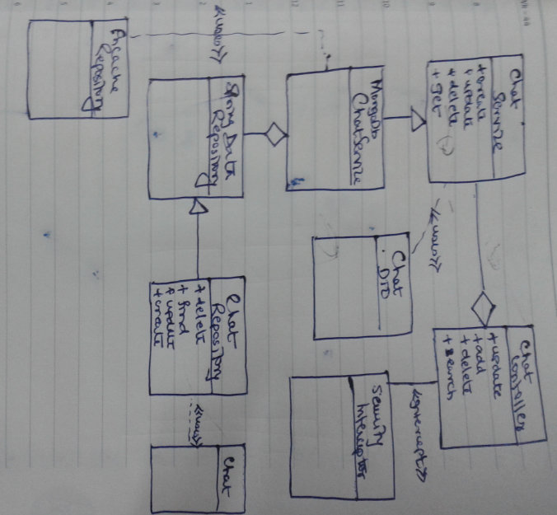

Interaction diagram for Chat service

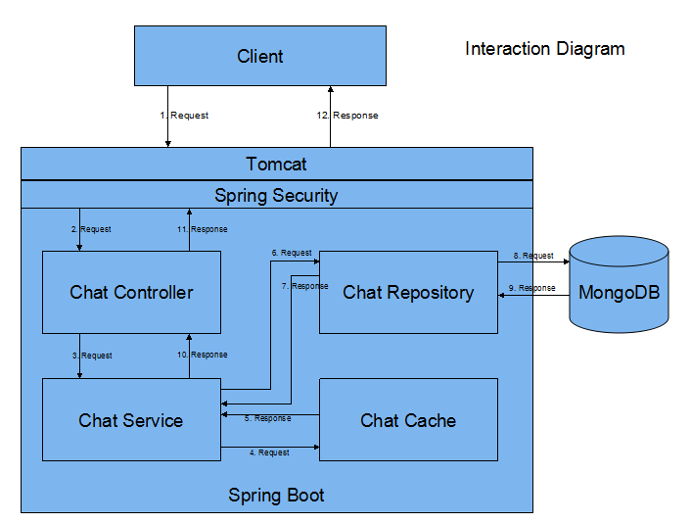

Technical diagram
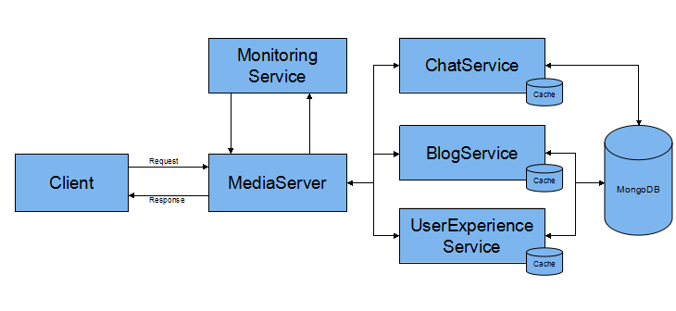

Here’s how application could be scaled and made highly available i.e. Just start a new instance of spring boot application i.e. Media service:

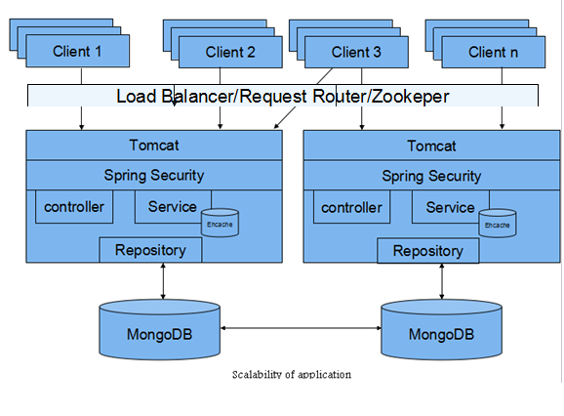

Technologies Used:
- Core Java (JDK8) - Base technology
- Spring Boot - Easy way to integrate all the webapplications, expose metrics, endpoints with minimal or no configurations.
- Spring Security - To authenticate and authorize user from using media system.
- Spring MVC - To help media service to expose rest enpoint for the clients.
- Spring actuator - To help us with metrics and monitoring the application.
- Ehcache - To cache the request from the user so we could take care of returning users at low latency.
- MongoDB - To store the documents submitted by the client.
- Mockito - To perform unit test by mocking dependencies.
- Junit - To perform unit test.
- Jbehave - To perform acceptance test.
- Jackson - To marshal and unmarshal client request and response.
- Logback - Logging framework
- Elastic search - Would be using it to index data, so we could do full search.

Design patterns used:

- Builder - Since Chat/Blogs has many attributes associated with it and we are just promoting immutability as we might soon be using these pojo’s across threads.
- Singleton - For Cache, MongoDB instance.
- Facade - slf4j for logging.
- Front controller - spring MVC to handle controller handling request.
- Factory - CacheConfigFactory to get instance of in memory or ehcache.
- DTO - data trandfer from repository to client.
- DAO - to access data from repository.

Requirement specifications:

- This system will be used by companies to share experiences, group chats, write blogs to share creative solutions, display streams of successful campaigns to see what is resonating with consumers,.etc.
We have exposed an api which expects data from the user and later persist documents form user onto MongoDB. Users can later on take the feed from MongoDB/Application and may use in further understanding analytics using Big data technologies like Hadoop, Sprink etc., learning system using Mahout. This system could later be used with mobile technologies where using rest user can get or post the data to this media system.

- How this application could be integrated with other:
  - This application can be used as plug and play. You could plug in any application like say browser accessing service by calling rest endpoint may be using Ajax.
  - Data in mongo DB could form a source to another data source like Elastic search or HDFS and could be used to do analytics based on Apache Spark or Hadoop.

- Users will have the ability to login, provide authentication and authorization.
Spring security will allow user to authorize to access the data or not.

